TT Secretary Report 2017
My typical tasks that run from year to year. In this case November 2016 - October 2017:
Ongoing: Storing and maintaining of club equipment, race numbers, marshal jackets, events signs, race flags, timing watches. Ensuring all documents are readily available for each planned event. Keep all records of Nomads events past winners, dates, times etc. Keep all event documents for 5 years.
From time to time we are required to supply marshals as part of our affiliation to SCCU, organise these marshals as requested.
Deal with any correspondence from CTT both locally and nationally, along with any from the local associations.
November: Write and submit TT Secretary report to be presented at the AGM.
Contact all previous year’s trophy winners to return annual trophies in readiness for re-engraving.
Release trophies claim form so that all of those who have competed in open events (events other than Nomad events) can inform TT Secretary of race records for the season.
Ensure that we have affiliated to CTT, SCA, ESCA and SCCU, and that fees have been paid.
Complete CTT levy form for Open events for HC, submit the form to CTT district treasurer, and arrange payment of the levies, usually by bank transfer.
December: compile list of trophy winners and times or points etc from the information submitted, and Nomads event records of the season.
Deliver all trophies (usually 6 weeks prior to the Dinner) to Geoff Smith along with details of engraving and replicas required, as Geoff has co-ordinated all the SCA trophies for many years and he has kindly managed our trophies with the engravers too.
Organise Xmas 10, this includes going around the course to complete a risk assessment for the event, erect signage as required by the governing body CTT, sign on the riders and collect their entry fees, time the event or arrange for another to do so in advance, and after the event publish the times on the Club’s website.
January: check all of the Open and Club events, that have been applied for the pervious September, appear in the CTT yellow book and that the information is correct. Check that our open HC appears on the CTT entry system and information is up to date, correct as required.
Complete Police notification forms for each and every one of our events applied for, a copy of each event going to both the Police traffic unit and CTT club event’s Secretary, these need to be in 42 days before the event, but easier to submit all at once.
Collect trophies back from Geoff Smith after engraving, check and clean as necessary in readiness for the prize presentation. Deliver to dinner for the presentation. After the dinner collect prizes that were not presented, and arrange delivery/collection to those winners.
April: end of April is the start of the Evening 10 series, check the course. This year, road works were still on the course, so all Police notification forms had to be resubmitted to reflect the shorter course.
Every Friday evening from end of April until August, organise TT events. This includes going around the course to complete a risk assessment for the event, erect signage as required by the governing body CTT, sign on the riders and collect their entry fees, time the event or arrange for another to do so in advance, and after the event publish the times on the Club’s website each week giving times and standings in the points system, and bank all takings into club account, usually by bank transfer.
This year because of the continued roadworks on the G10/99 I started looking with the help of Richard Burdett, to submit a new course for our club events to the CTT, so by the end of May, a favourable course was submitted to CTT for their approval. After they completed risk assessments and course measurements, we received approval at the beginning of September.
September: organise Club 5-mile TT, pressgang another to help with timing, and do all the task’s as per all other club TT’s.
Submit the Nomads application to run the Open Hill Climb, (in this case for 2018 HC) copy below already submitted.
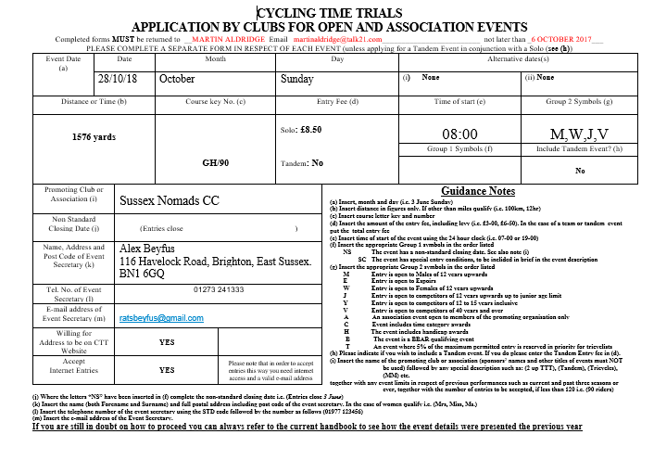
Check CTT schedule for running Open Hill Climb that we, as a club, have complied with all requirements to date. Offer assistance and knowledge where required to Alex Beyfus for running 2017 HC. Continue to Support Alex during the month running up to the HC, and on the day.
October: submit Nomads application to hold Club events during 2018 copy below already submitted.
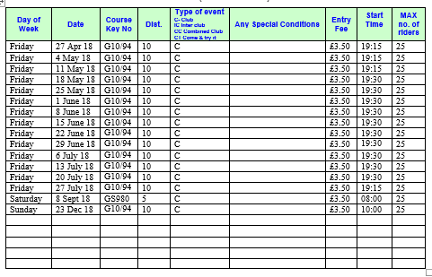
You will notice that the 25-mile TT has been replaced with an additional 10, the reason is not being able to find a new 25 course in time for the submission of the application, and also not wanting to return to the Wineham courses in 2018. We can arrange to use an Open event for the Club 25 during 2018, if the members wish so.
Complete CTT levy form for Club events, submit the form to CTT district treasurer, and arrange payment of the levies, usually by bank transfer.
-----------------------------
In the event that a replacement for a new TT Secretary for 2018 is not forthcoming at this year’s AGM, (I am not presuming to be re-elected) but I am prepared to stand for another single year, after which a replacement will have to be found.
Adrian Morris
TT Secretary

